Introduction to cloud computing

# Week 1

5 Essential characteristics of cloud computing:

* On demand self-service
* Broad Network Access
* Resource Pooling
* Rapid Elasticity
* Measured Service

3 types of cloud deployment models

* Public: leverage cloud services over the open internet on hardware owned by the cloud provider, but its usage is shared by other companies.
* Private: the cloud infrastructure is provisioned for exclusive use by a single organization. It could run on-premises or it could be owned, managed, and operated by a service provider.
* Hybrid: mix of both public and private clouds, working together seamlessly.

3 service models

* IaaS infrastructure as a service: You get access to infrastructure and physical computing resources such as servers, networking, storage, and data center space – without the need to manage or operate them.
* PaaS platform as a service: You get access to the platform, that is the hardware and software tools, usually those needed to develop and deploy applications to users over the internet.
* SaaS application as a service: Is a software licensing and delivery model in which software and applications are centrally hosted and licensed on a subscription basis, and sometimes also referred to as “on-demand software”

Virtualization

Hypervisor (separating hardware and system)

Pay as you go

From Capital Expense to Operating Expense.

Key benefits of cloud computing

* Agility
* Flexibility
* Competitiveness

Cloud computing is the delivery of on-demand computing resources over the internet on a pay-as-you-go basis; resources are dynamically assigned and reassigned among multiple users and scale up and down in response to users’ needs.

The origins of cloud computing can be traced back to the mainframes of the 1950s, with virtualization technologies and hypervisors serving as catalysts for the emergence of modern-day cloud computing.

Organizations must consider their business needs, investment viability, and risk capacity in order to create a cloud adoption strategy that delivers desired benefits without causing business disruptions and security, compliance, or performance issues.

Cloud adoption is growing faster than predicted. Driving this technological wave are cloud service providers with a host of services ranging from Infrastructure, Platform, and Software services. Some major Cloud providers of our times include AWS, Alibaba Cloud, Google, IBM, and Microsoft Azure.

The adoption of cloud technologies is enabling enterprises, big and small, to be agile, innovative, and competitive, and to create differentiated customer experiences. The question organizations are asking is not whether they should move to the cloud, rather what strategy they should adopt to move to the cloud.

Some case studies that demonstrate the impact businesses have created by adopting cloud:

American Airlines adopting cloud technologies to deliver customer value rapidly across its enterprise

UBank leveraging cloud platform services to give more control to their developers thereby removing barriers to innovation

Bitly leveraging the scalability offered by cloud infrastructure for low-latency delivery to its geographically disbursed enterprise customers

ActivTrades leveraging the infrastructure, storage, network, and security offerings on the cloud to accelerate execution and delivery of new functions in their online trading systems to their customers

Emerging technologies, powered by the cloud, are disrupting existing business models and creating unprecedented opportunities for businesses to grow, innovate, and create value for their customers.

Some case studies that demonstrate how the use of emerging technologies on the cloud is creating value for millions around the world:

The use of the Internet of Things on the cloud to combat poaching of endangered rhinos in South Africa

Artificial Intelligence on the cloud being leveraged to deliver unique digital experiences to millions of fans around the world by the United States Tennis Association

Blockchain on the cloud helping farmers reduce waste by building traceability and transparency in the food supply chain

The use of data analytics for driving predictive maintenance solutions for a city’s infrastructure by KONE

5 Essential characteristics of cloud computing:

* On demand self-service
* Broad Network Access
* Resource Pooling
* Rapid Elasticity
* Measured Service

# Week 2

## 3 service models

* IaaS infrastructure as a service: You get access to infrastructure and physical computing resources such as servers, networking, storage, and data center space – without the need to manage or operate them.

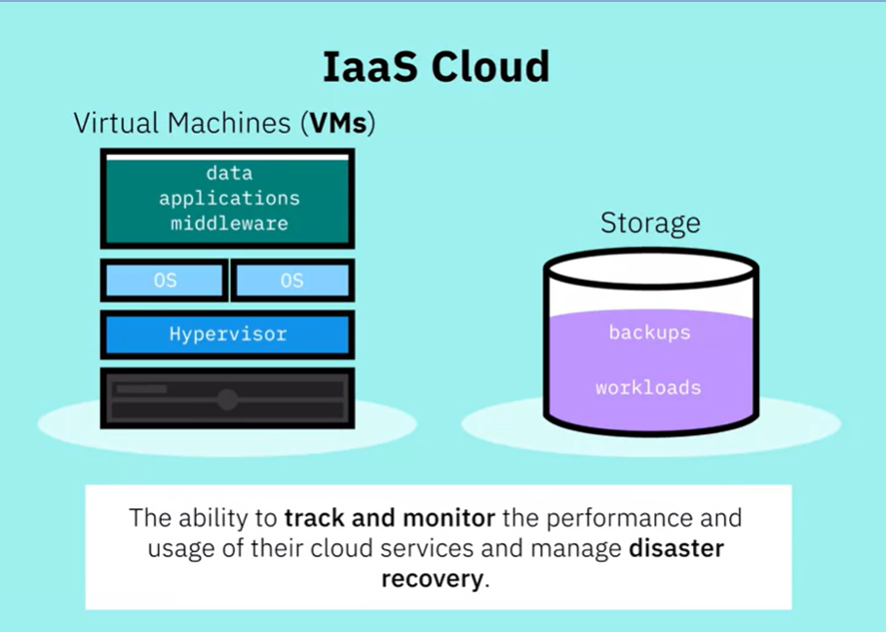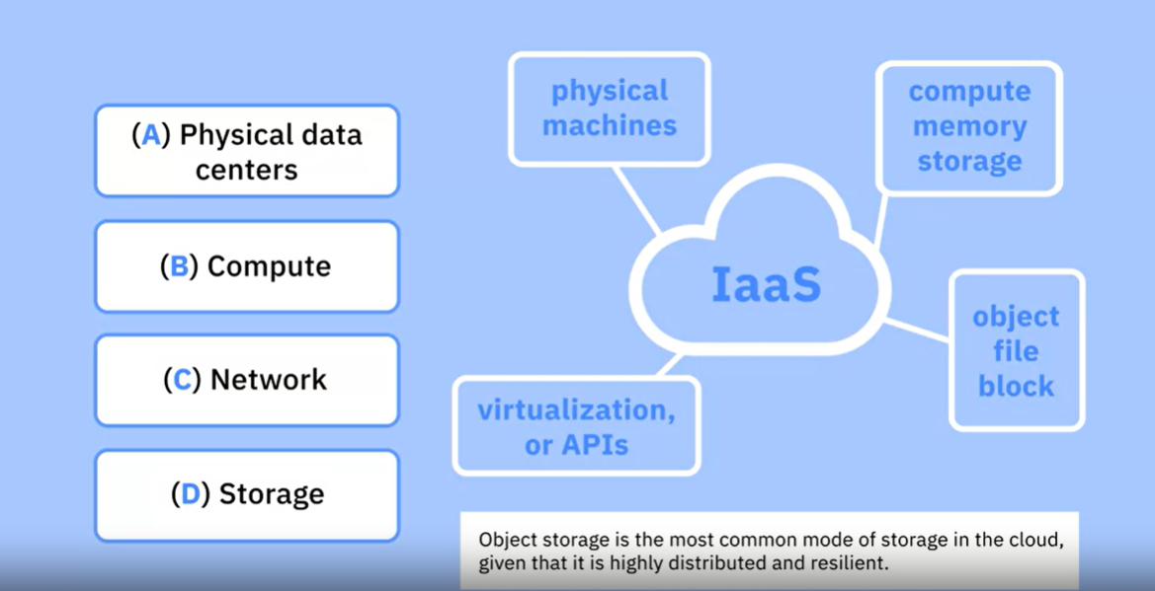

* PaaS platform as a service: You get access to the platform, that is the hardware and software tools, usually those needed to develop and deploy applications to users over the internet.

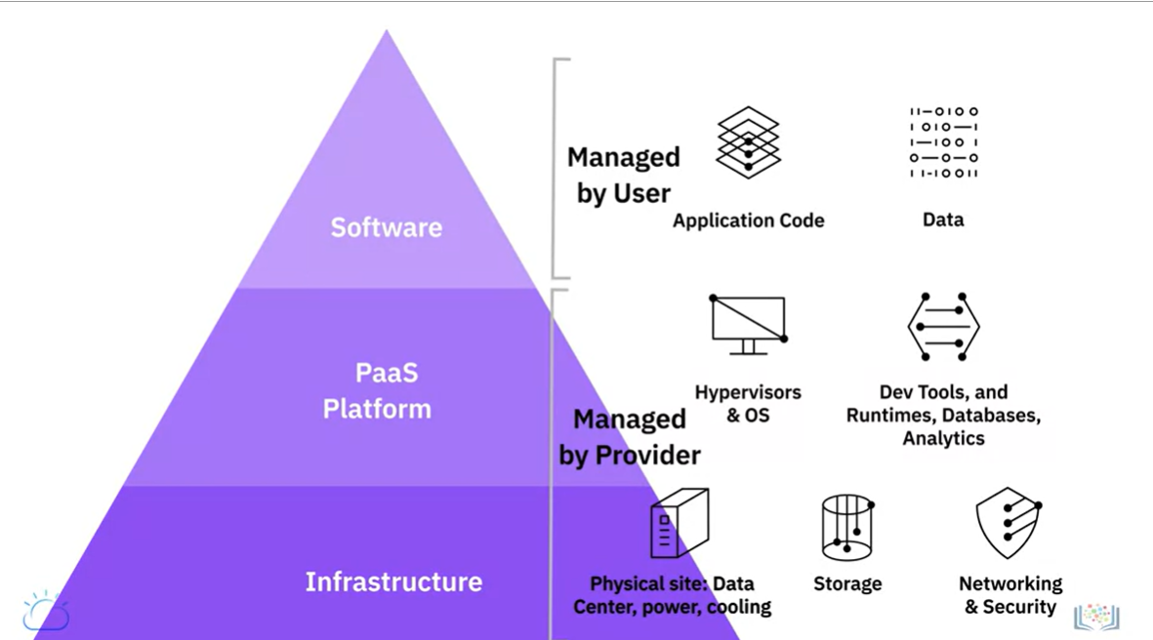

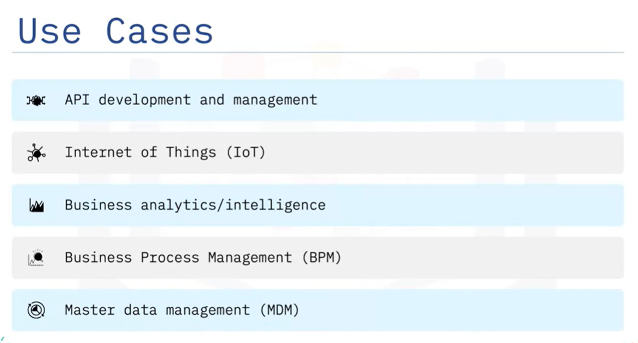

* SaaS application as a service: Is a software licensing and delivery model in which software and applications are centrally hosted and licensed on a subscription basis, and sometimes also referred to as “on-demand software”

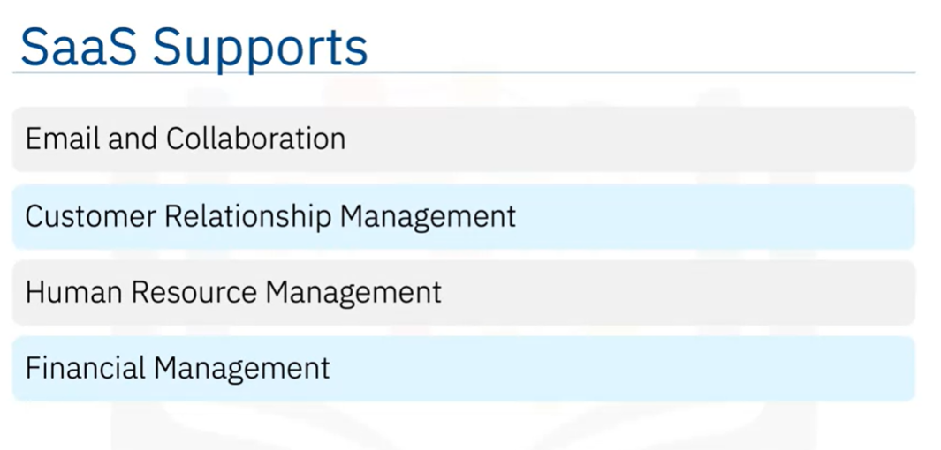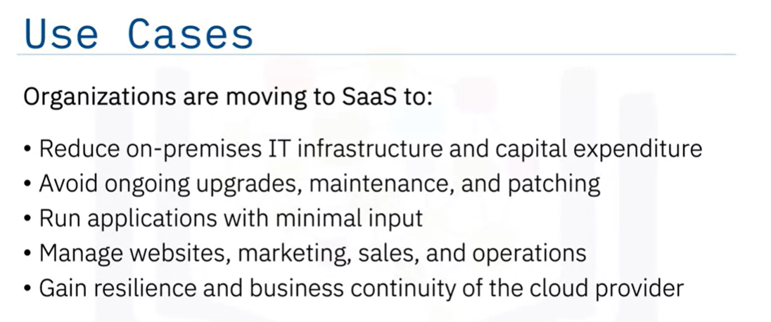

Cloud computing allows us to utilize technology as a service, leveraging remote resources on-demand, on a pay-as-you-model. There are three main service models available on the cloud—Infrastructure-as-a-Service (IaaS), Platform-as-a-Service (PaaS), and Software-as-a-Service (SaaS).

IaaS provides the fundamental compute, network, and storage resources for customers on-demand.

PaaS provides customers the hardware, software, and infrastructure to develop, deploy, manage, and run applications created by them or acquired from a third-party.

SaaS provides access to users to a service provider’s cloud-based software. Users simply access the applications on Cloud while the Cloud provider maintains the infrastructure, platform, data, application code, security, availability, and performance of the application.

## 3 types of cloud deployment models

* Public: leverage cloud services over the open internet on hardware owned by the cloud provider, but its usage is shared by other companies.

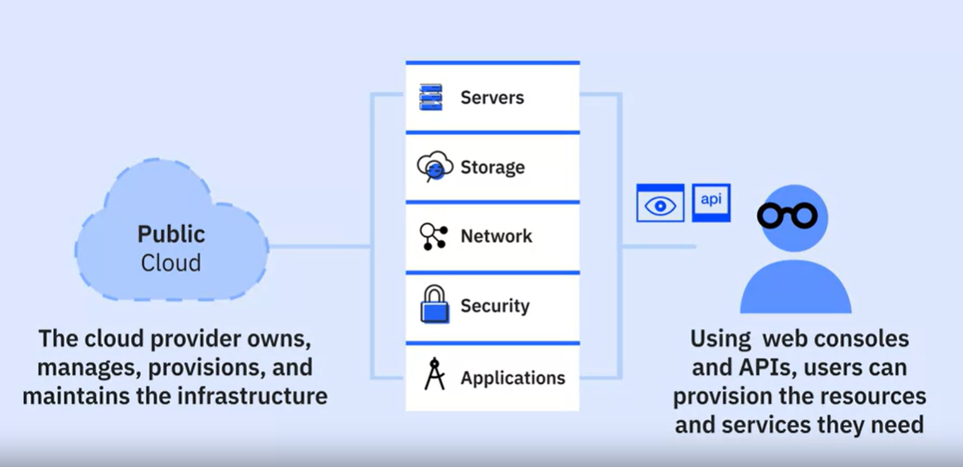

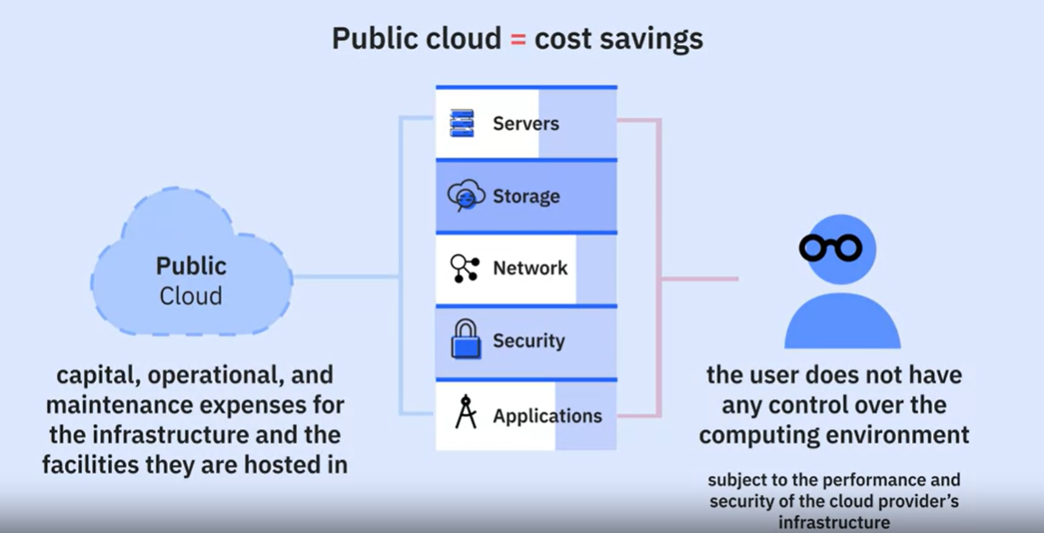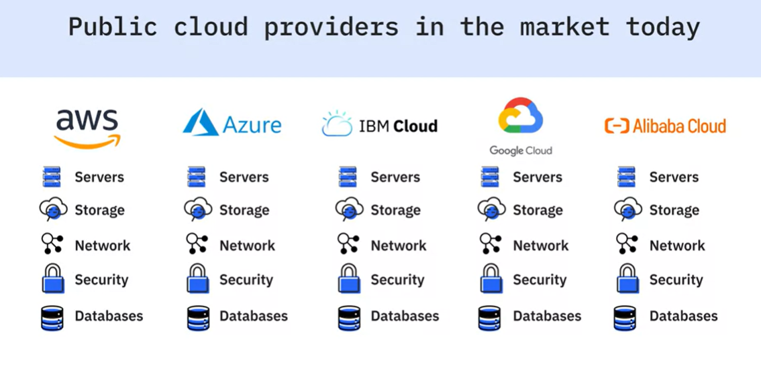

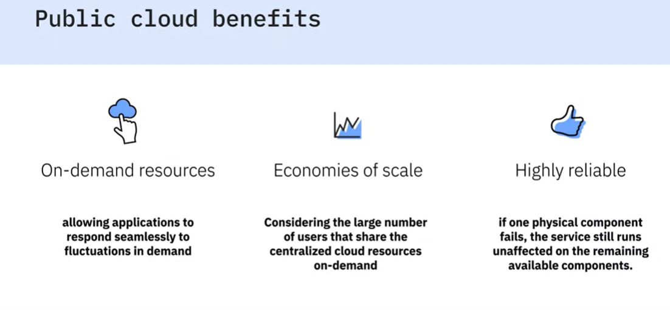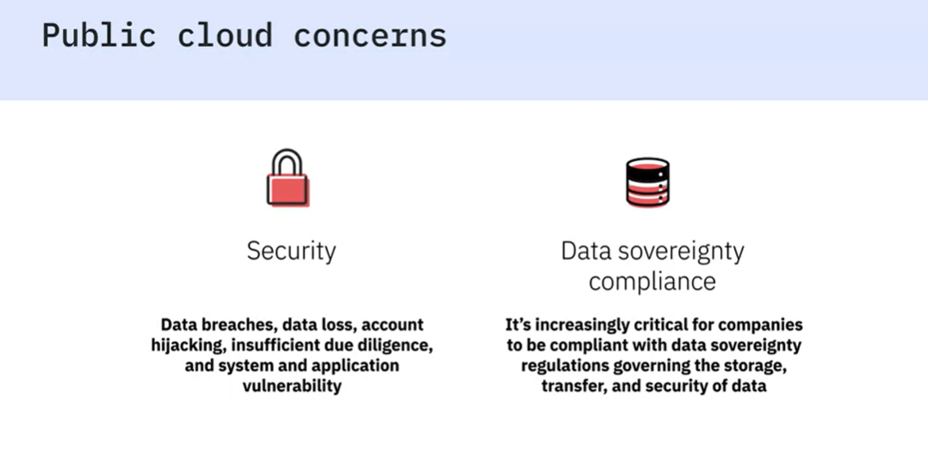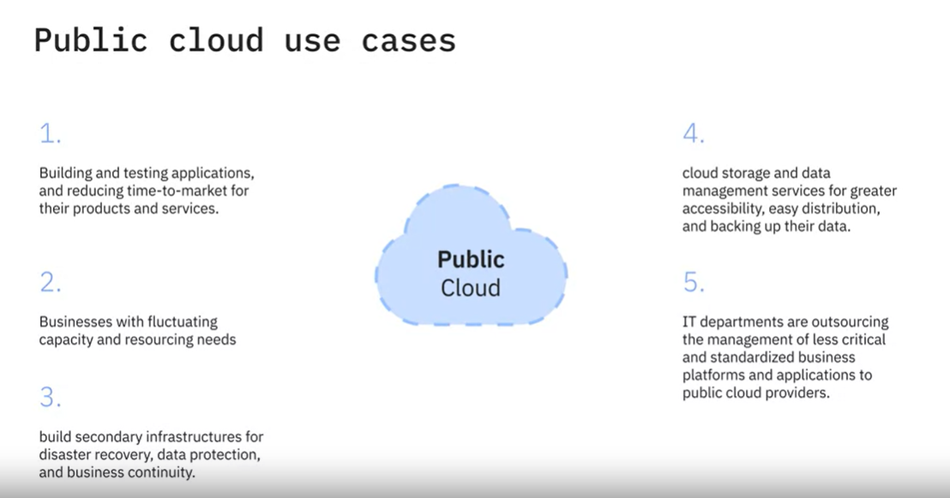

* Private: the cloud infrastructure is provisioned for exclusive use by a single organization. It could run on-premises or it could be owned, managed, and operated by a service provider.

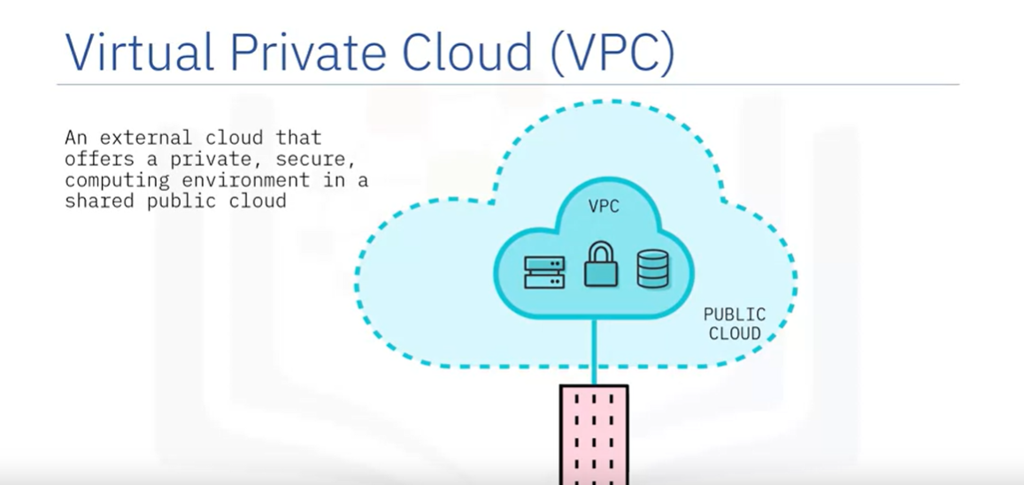

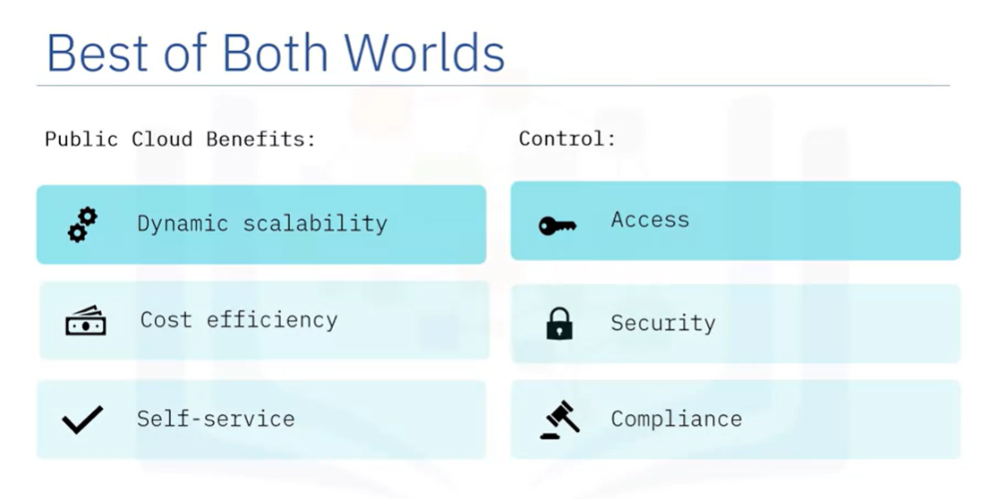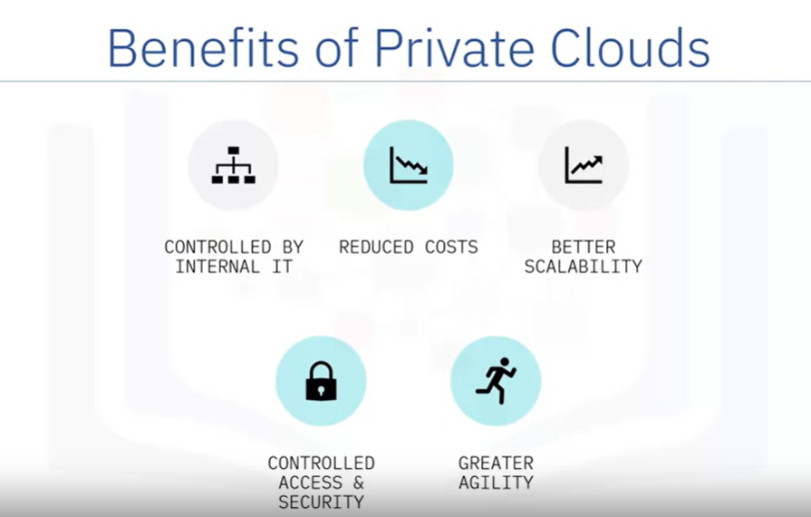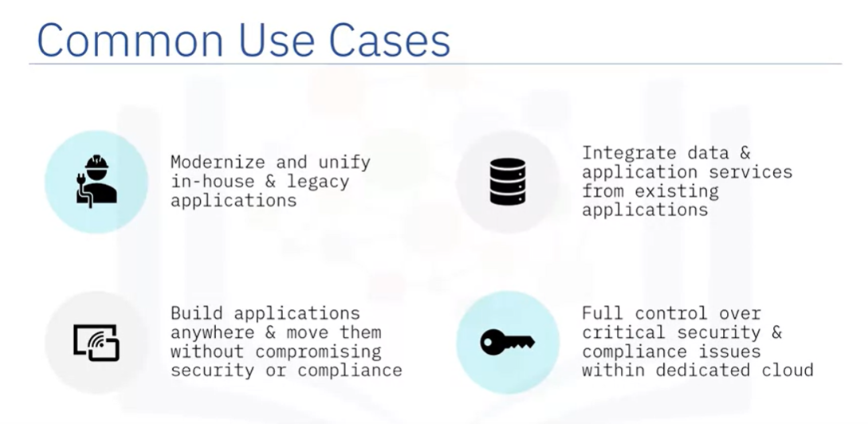

* Hybrid: mix of both public and private clouds, working together seamlessly.

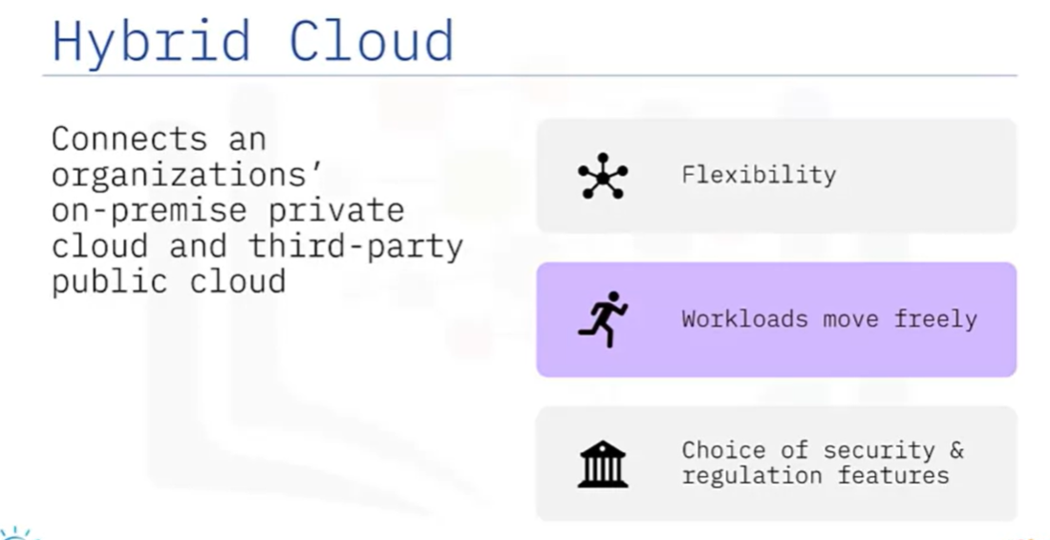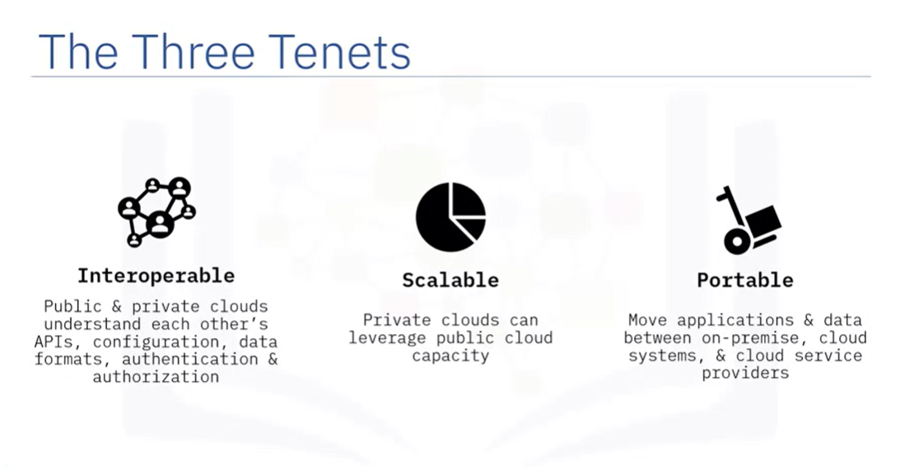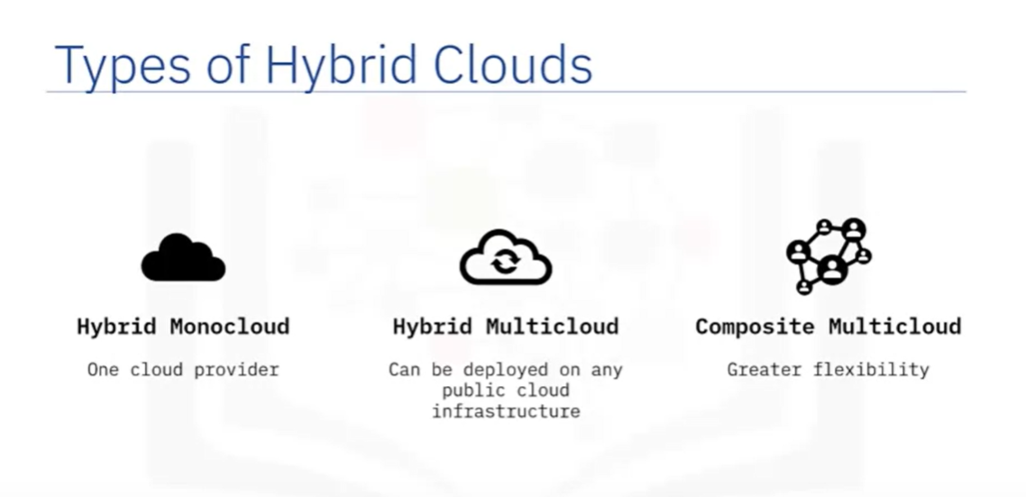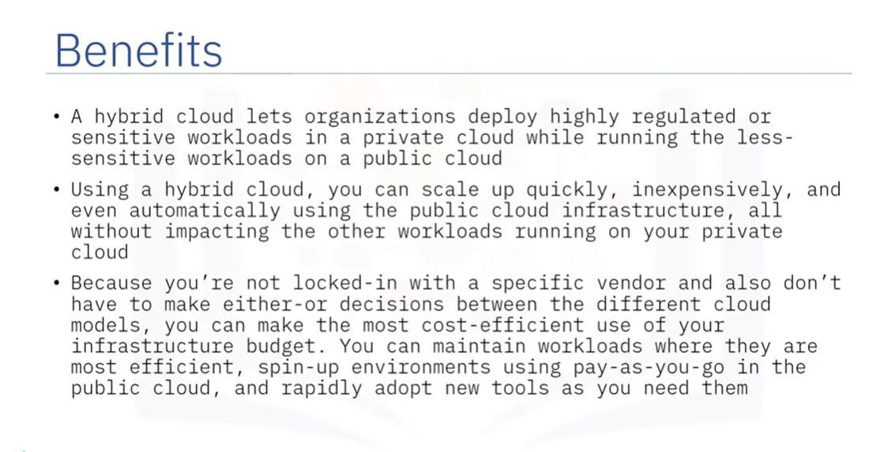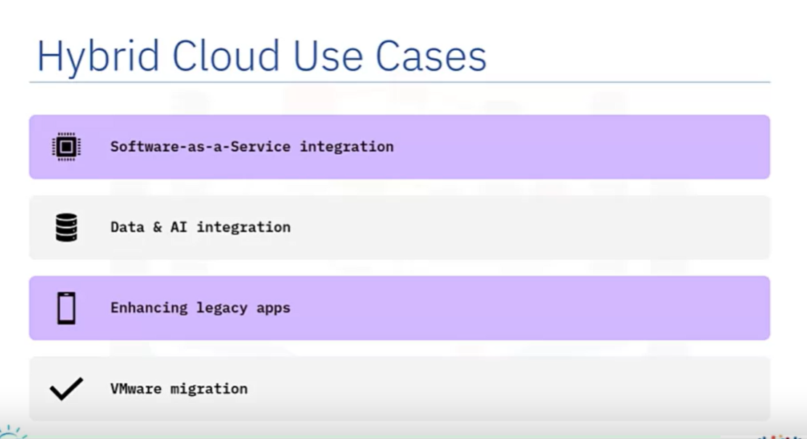

Deployment models indicate where the infrastructure resides, who owns and manages it, and how cloud resources and services are made available to users. There are three main deployment models available on the cloud—Public, Private, and Hybrid.

In the Public cloud model, the service provider owns, manages, provisions, and maintains the physical infrastructure such as data centers, servers, networking equipment, and storage, with users accessing virtualized compute, networking and storage resources as services.

In the Private cloud model, the provider provisions the cloud infrastructure for exclusive use by a single organization. The private cloud infrastructure can be internal to the organization and run or on-premises. Or, it can be on a public cloud, as in case of Virtual Private Clouds (VPC) and be owned, managed, and operated by the cloud provider.

In the Hybrid cloud model, an organization’s on-premise private cloud and third-party, public cloud is connected as a single, flexible infrastructure leveraging the features and benefits of both Public and Private clouds.

# Week 3

## Overview of Cloud Infrastructure

Computing resources

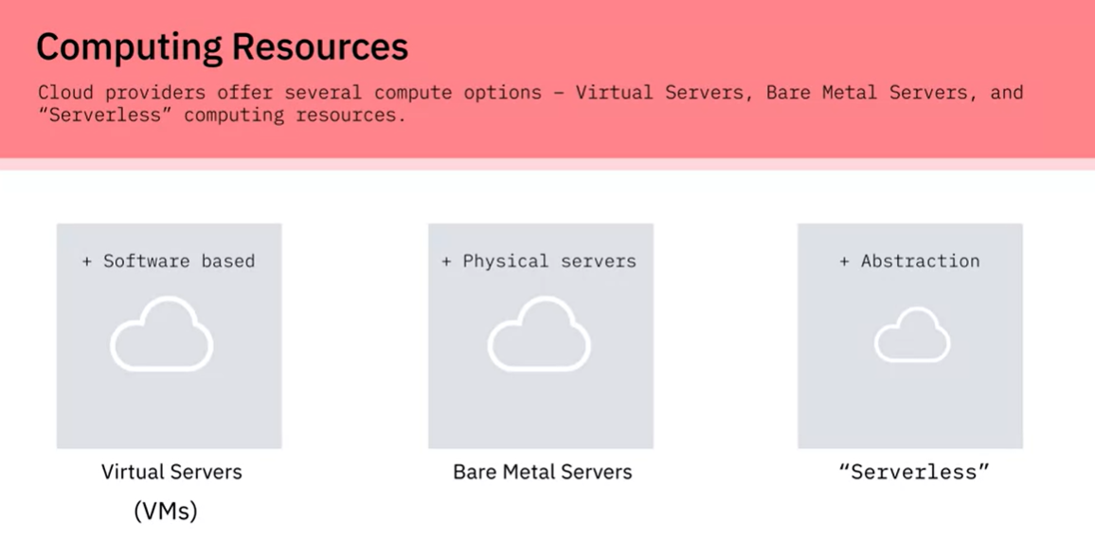

Storage

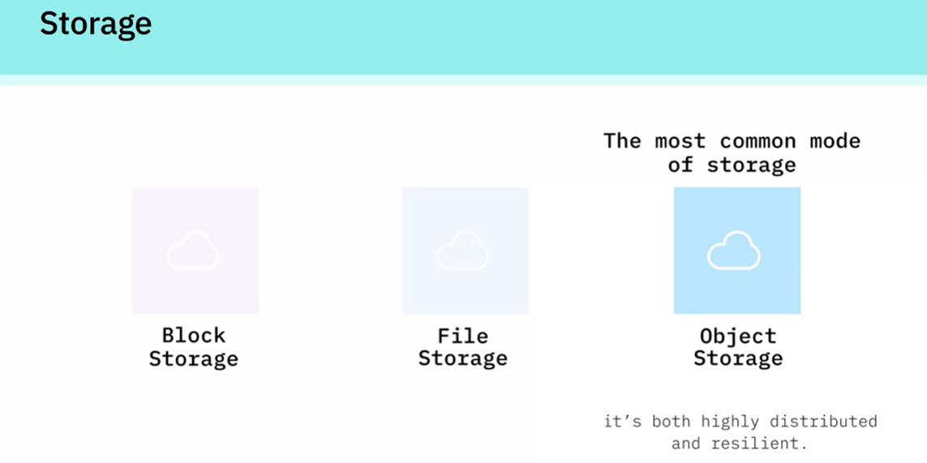

Networks

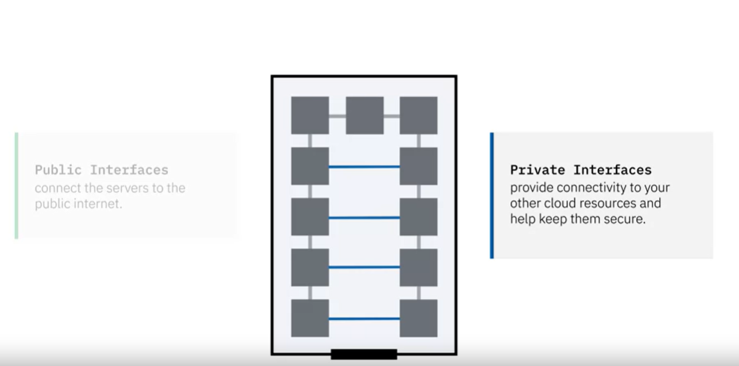

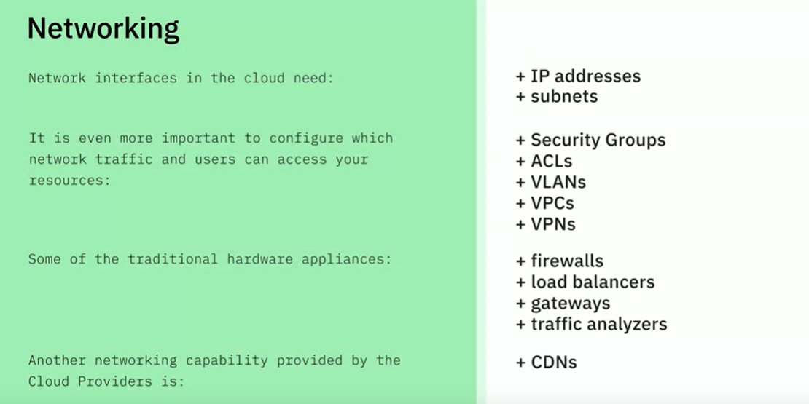

## Virtualization and Virtual Machines

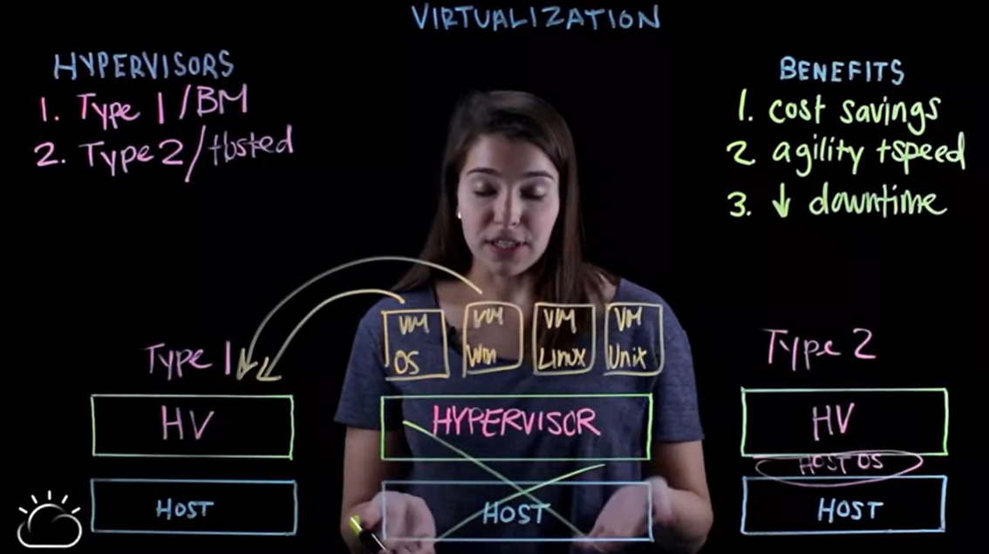

## Types of Virtual Machines

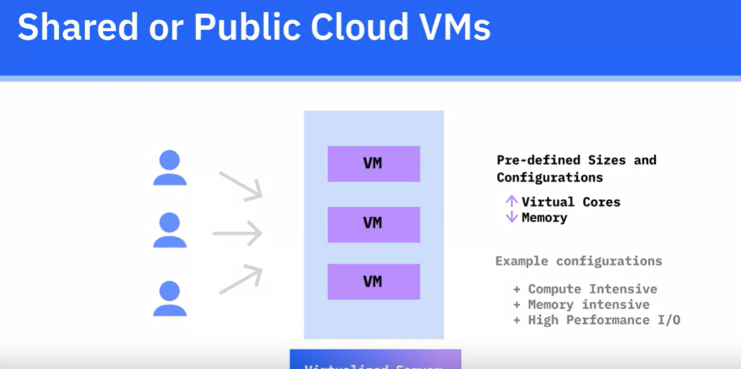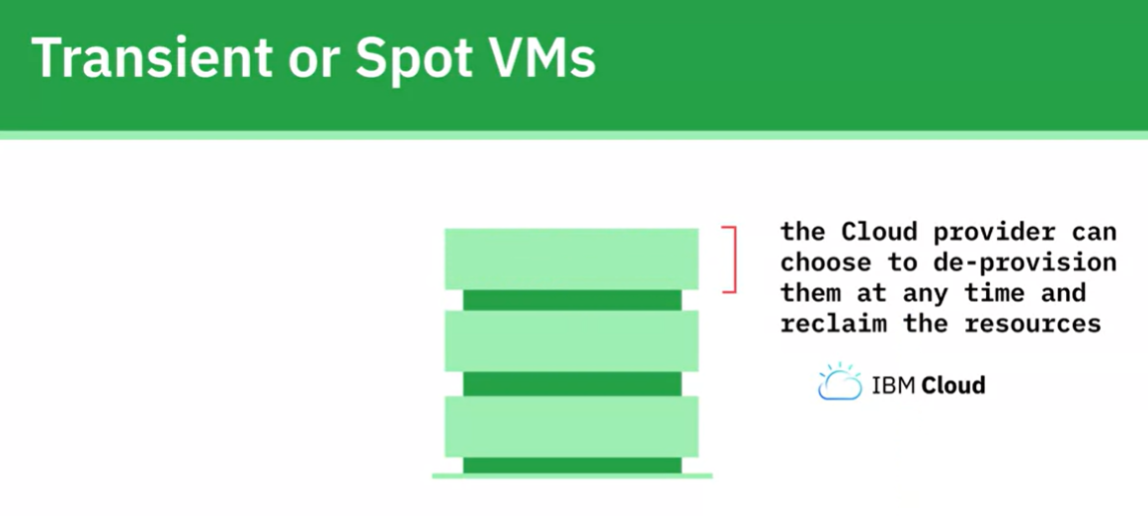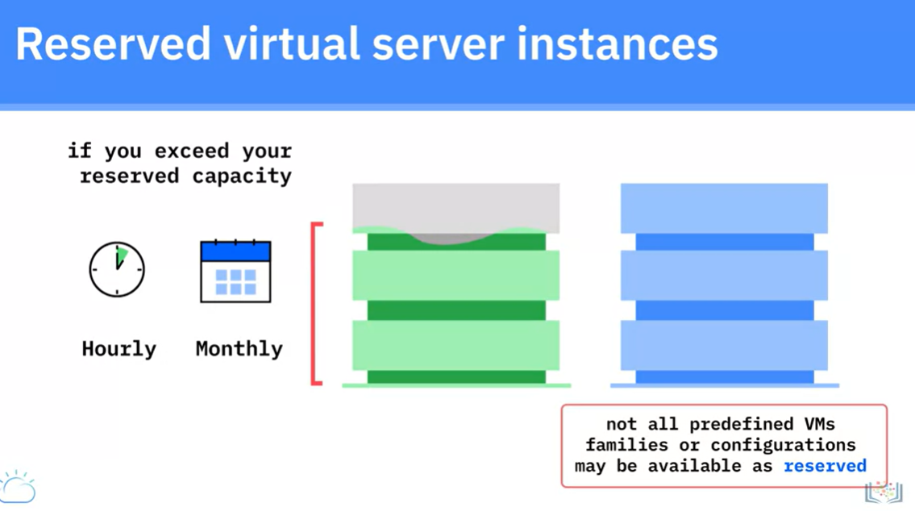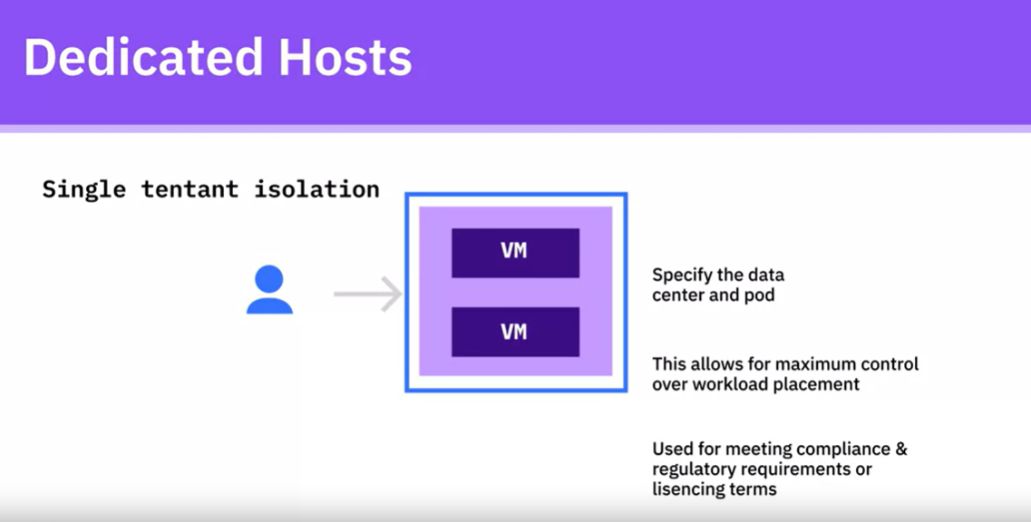

### Bare mental servers

Needs more time to configure.

Everything is under control

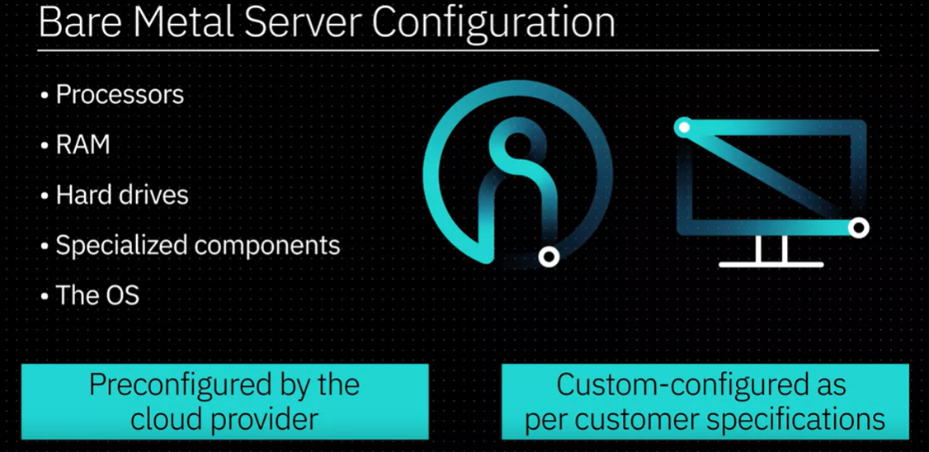

### Workloads

No hypervisor required

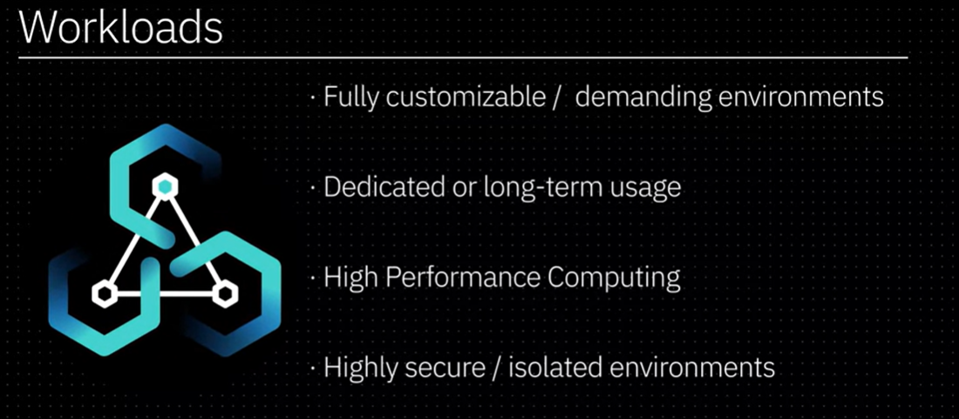

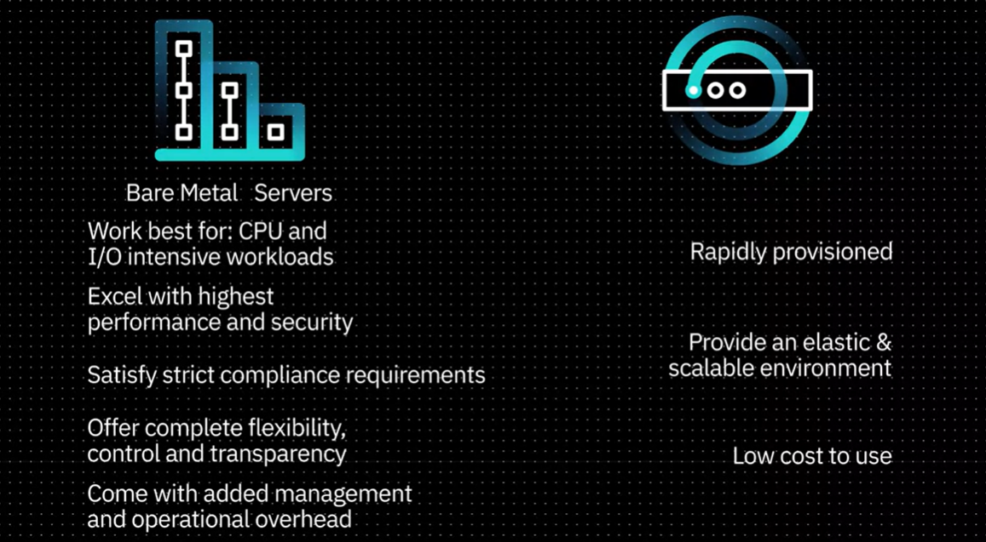

### Virtual private clouds

Subnets

Security is required

### Container technology

## Storage on Cloud

Faster speed is higher price IOPs (Input and output per seconds)

### Direct Attached

Local storage in same rack

Not resilient 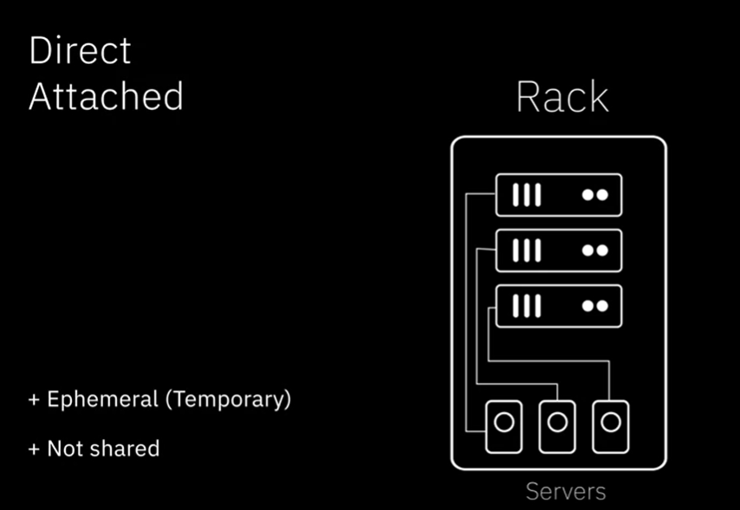

### File Storage

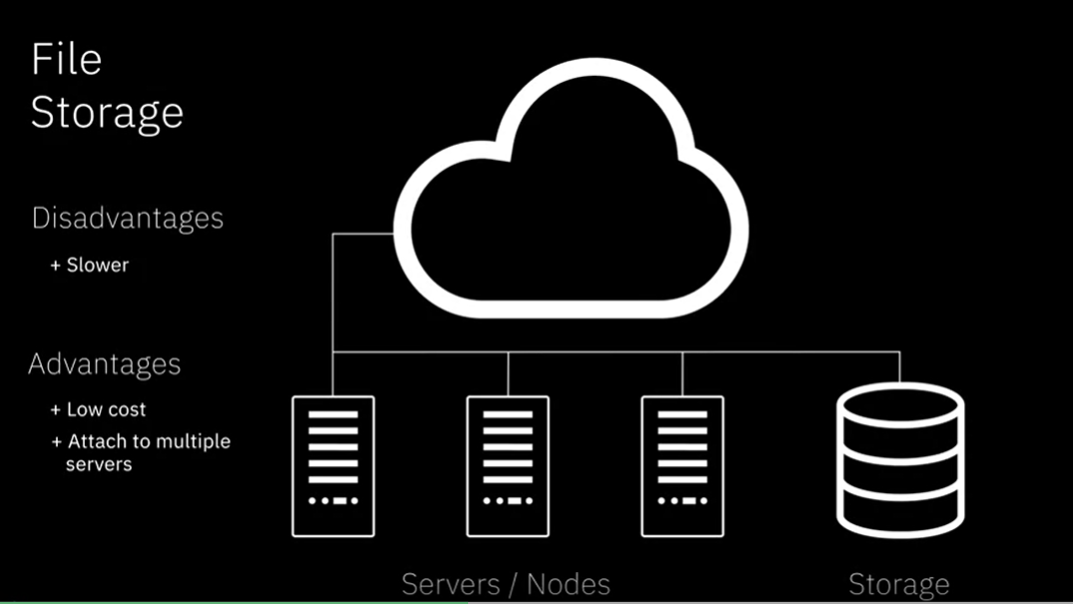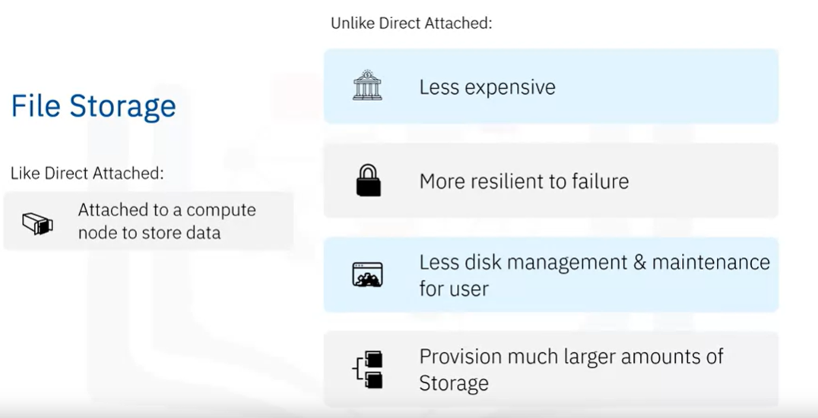

### Timeline Description automatically generatedGraphical user interface, application Description automatically generatedBlock Storage

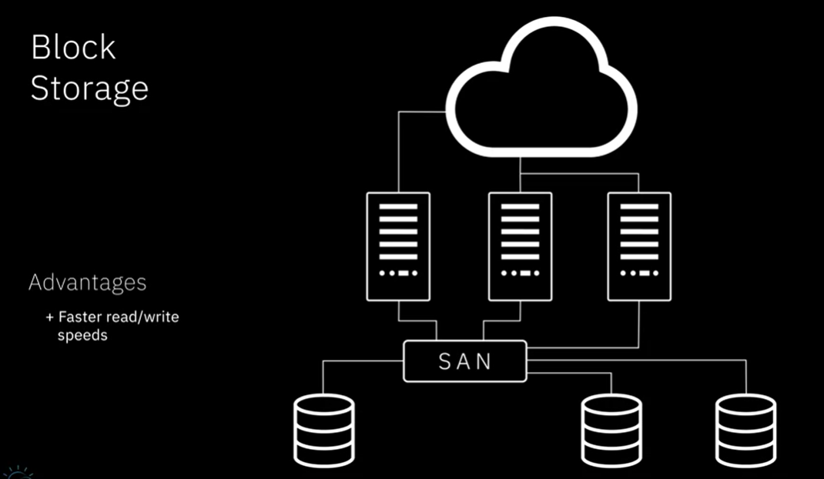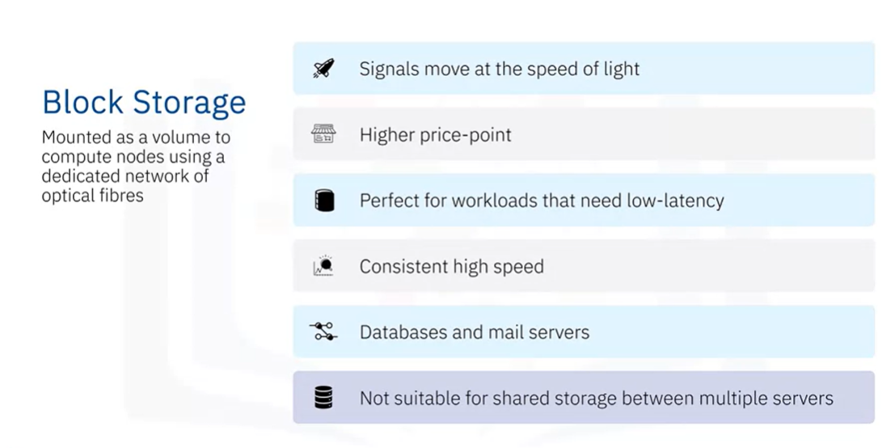

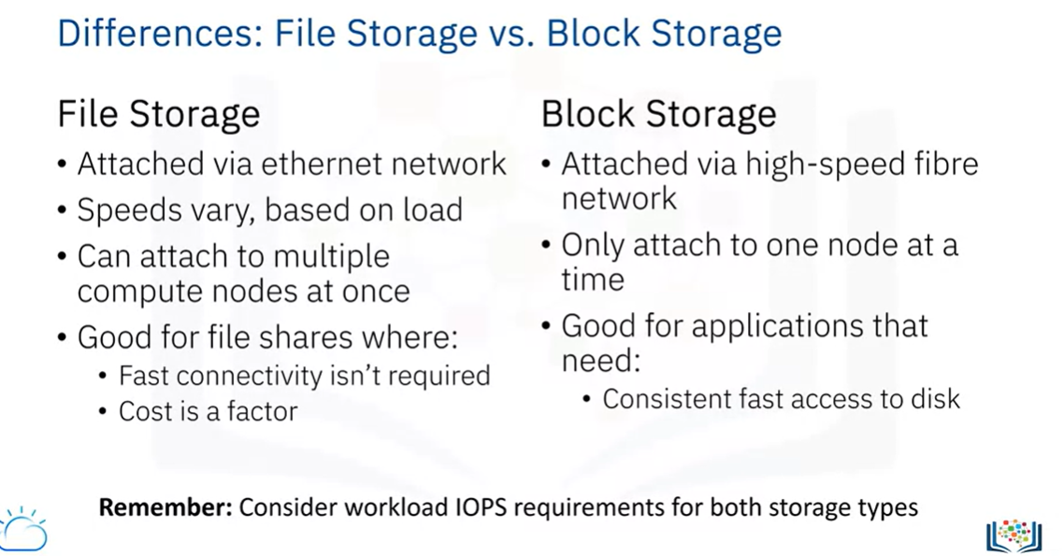

Persistence: What happened to the storage once the compute node it is attached to is terminated.

Snapshot: A point in time image of the storage.

* Fast to create
* Don’t require down time
* Record only changes to data
* Cannot recover individual files

### Object Storage

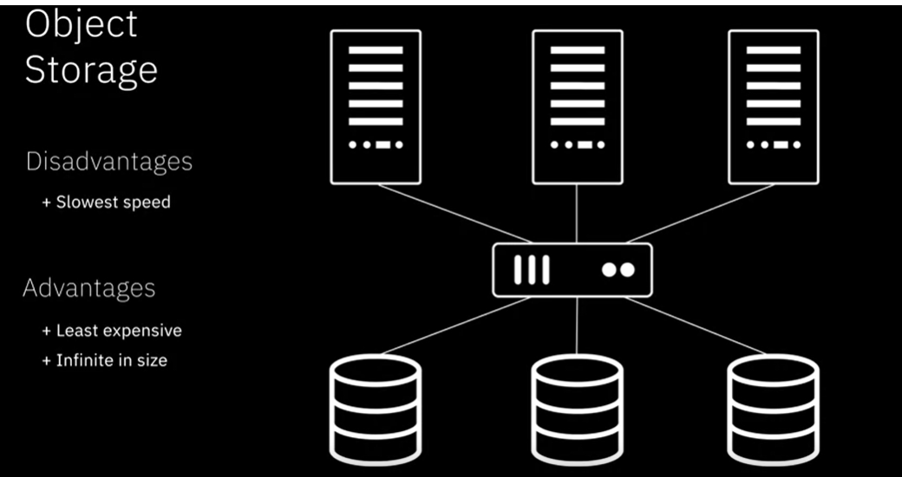

Key characteristics:

* Object storage can be used without connecting to a particular compute node to use it.
* Object storage is less expensive than other cloud storage options.
* Almost infinite

The data is only stored in one data centre:

* Data resided in a particular geographical location
* Used in situations where high availability is less of an issue

The data is stored multiple times in different datacentres

* In same region or even across multiple regions
* Usually cost more but provide highest levels of resilience as well as availability

It seems that Object storage is tape storage..

#### Tiers and APIs

Standard Tier - Frequent access

Vault/Archive Tier – Store objects that are accessed once or twice a month

Cold Vault Tier – Cheapests

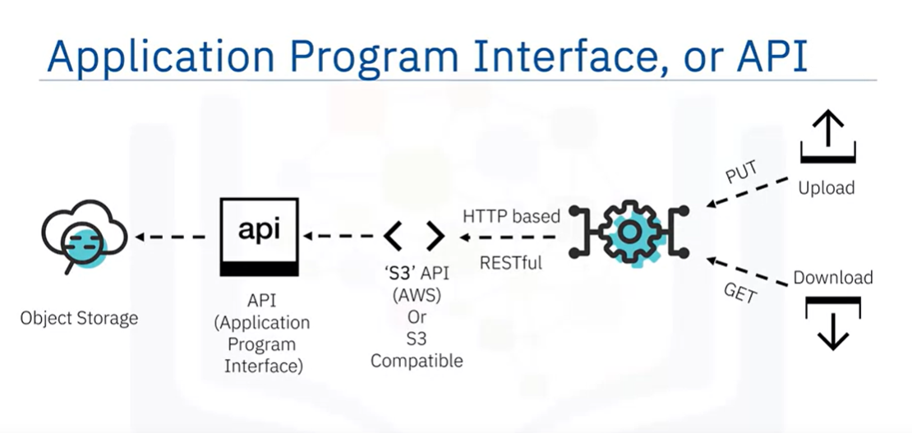

### Content delivery network

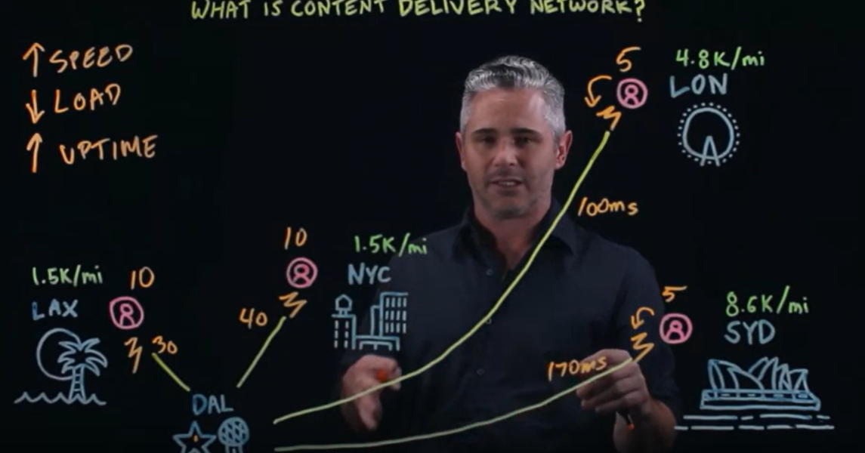

Cloud storage is available in four main types–Direct Attached, File, Block, and Object Storage. These storage types differ in how they can be accessed, the capacity they offer, how much they cost, the types of data they are best suited to store, and their read-write speed.

Direct Attached (or Local) Storage is storage that is presented directly to a cloud-based server and is effectively either within the host server chassis or within the same rack.

File Storage is typically presented to compute nodes as a Network File System (NFS), which means that the storage is connected to compute nodes over a standard ethernet network.

Block Storage is presented to compute nodes using high-speed fiber connections, typically provisioned in volumes, which are mounted onto a compute node.

Object Storage is accessed via an API and doesn’t need an underlying compute node. Object Storage offers infinite capacity as you can keep adding files to it and just pay for what you use. Compared to the other storage types, object storage is slowest in terms of read and write speeds.

A Content Delivery Network (CDN) is a distributed server network that accelerates internet content delivery by delivering temporarily stored or cached copies of website or media content to users based on their geographic location.

# Week 4

## Hybrid Multi-cloud

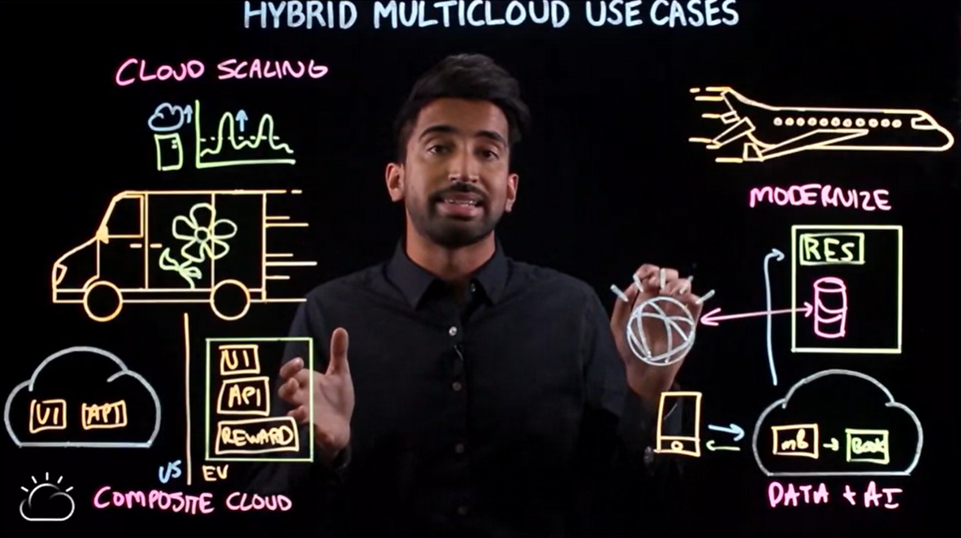

Micro-services: distributed services with individual units.

Serverless: don’t need to actually deploy server, use server manager.

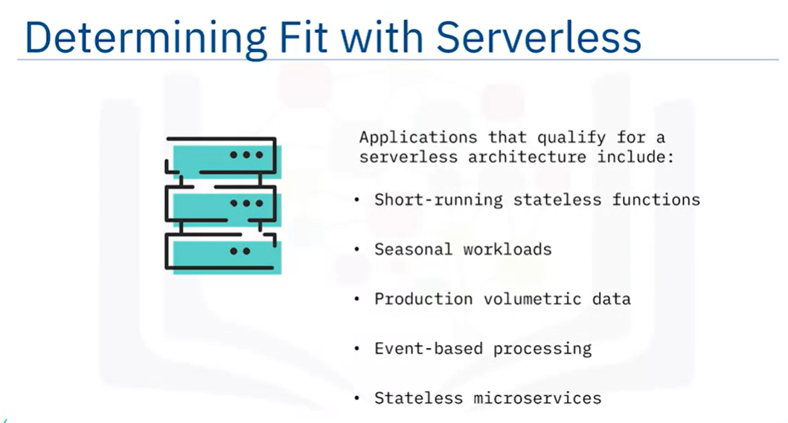

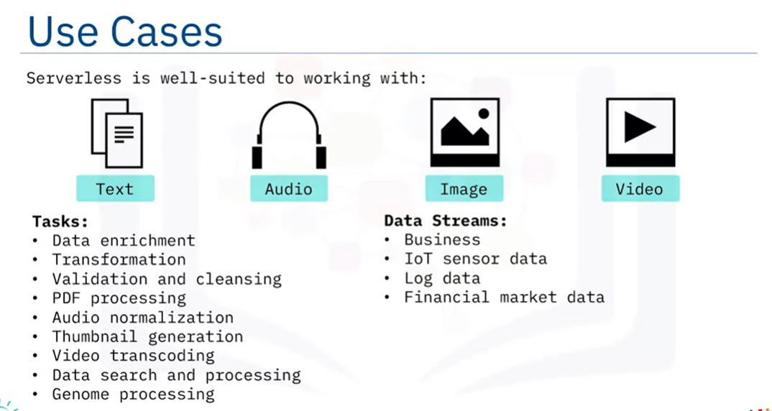

Hybrid Multicloud is a cloud adoption strategy that makes it possible for public clouds, private clouds, and on-premises IT to interoperate seamlessly while leveraging the best cloud-based services from different public cloud providers.

Microservices architecture is an approach in which an application is built as a collection of loosely coupled and independently deployable components or services, leading to efficient development, maintenance, and upgradation cycles.

Serverless Computing is an approach to computing that offloads responsibility for common infrastructure management tasks for application runtimes to cloud providers, allowing developers to focus their time and effort on development and testing, and not have to worry about provisioning, maintaining and scaling compute resources.

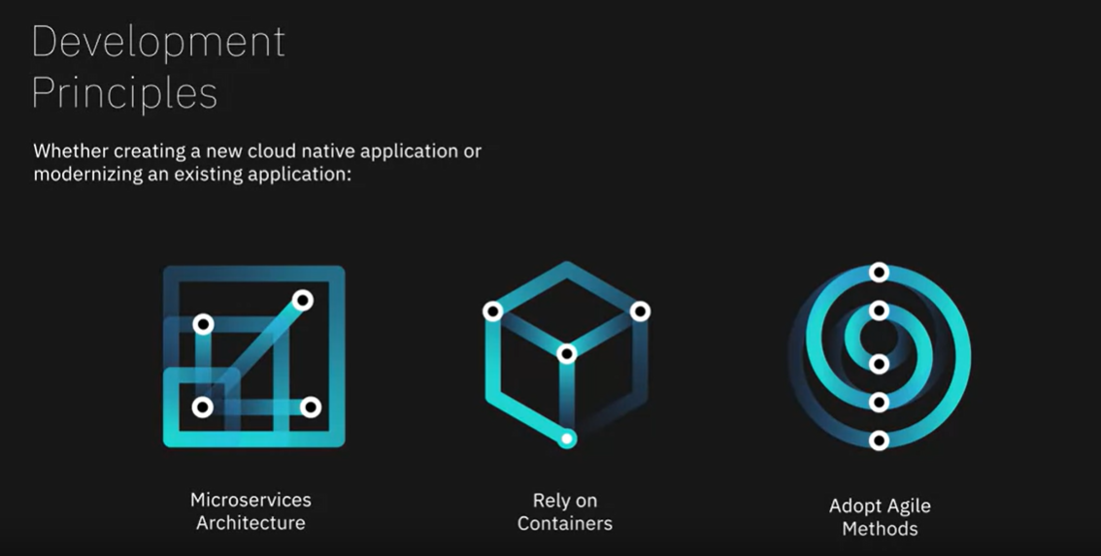

## Cloud Native Applications

Application (like microservices) that is designed to work on clouds

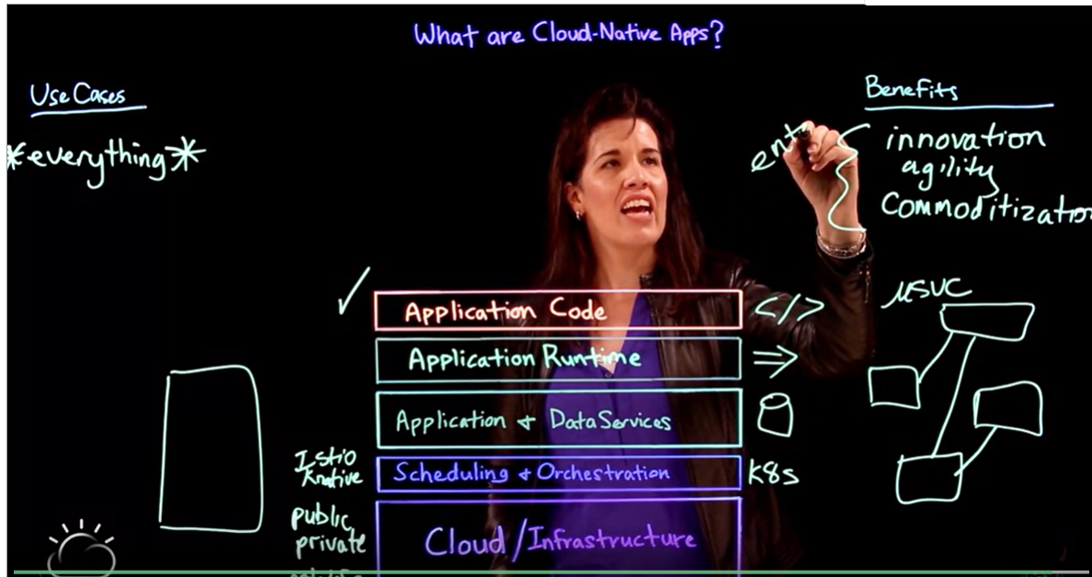

### DevOps

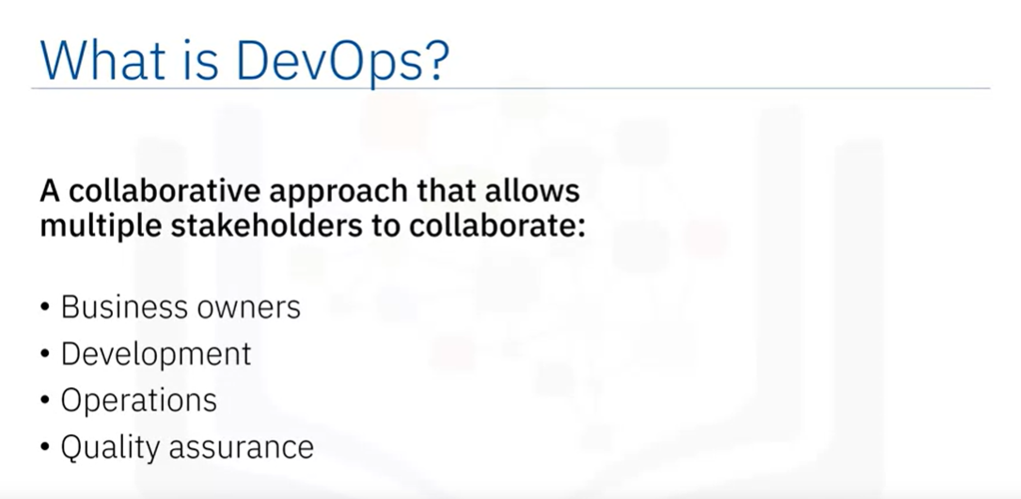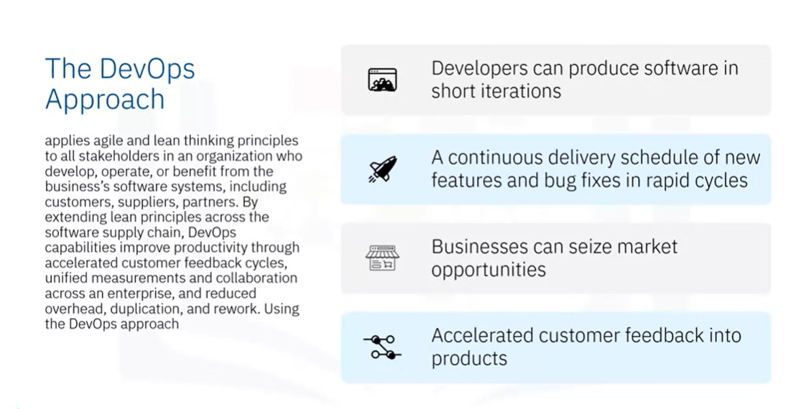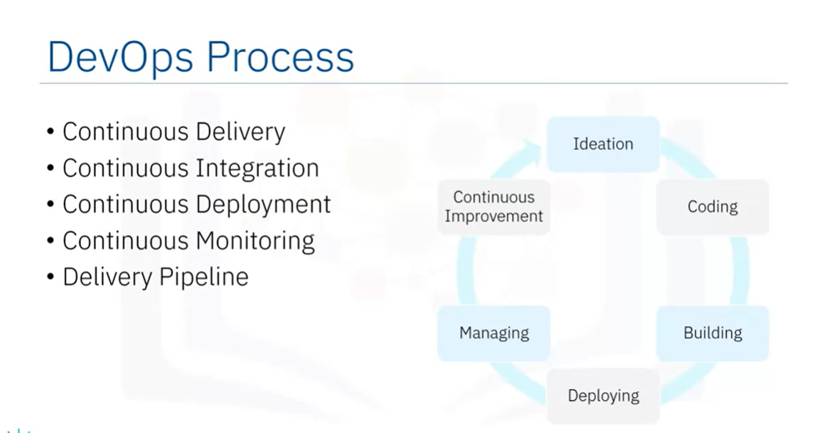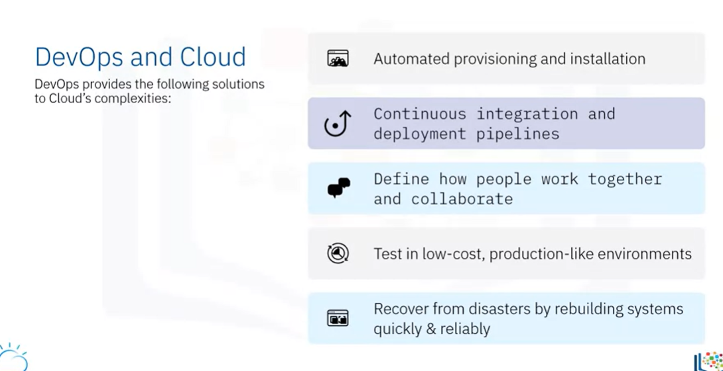

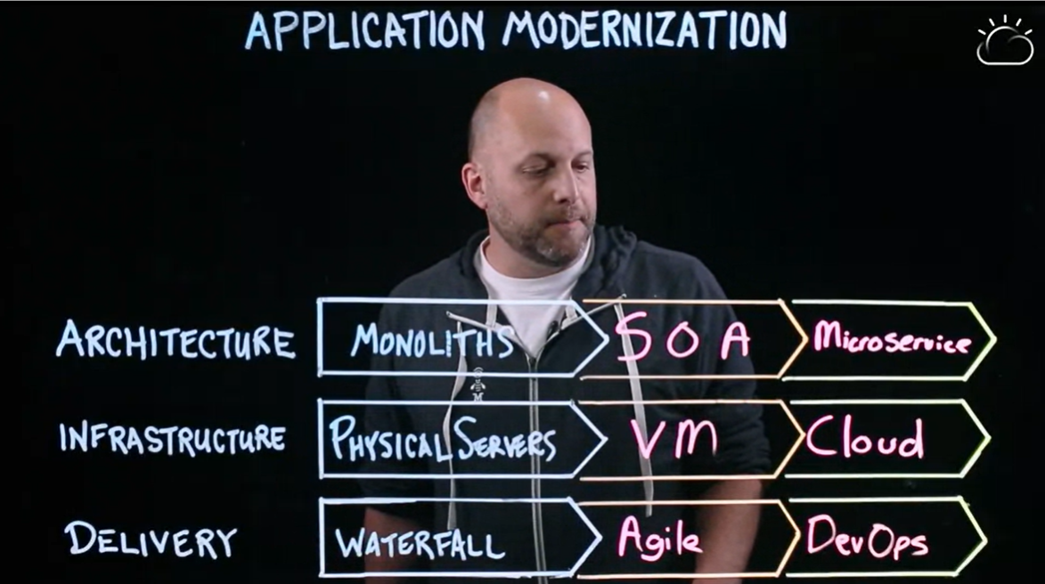Cloud native applications are applications that are built or refactored to work in the cloud environment. These applications, developed using DevOps methodologies, consist of microservices packaged in containers that can run in any environment—making it possible to create and update features in quick iterative cycles.

DevOps is a collaborative approach that enables development and operations teams to continuously deliver software in quick iterative cycles while reducing overhead, duplication, and rework. DevOps’ tools, practices, and processes help tackle the complexities and challenges posed by the cloud, allowing solutions to be delivered and updated —quickly and reliably.

Application Modernization helps organizations accelerate their digital transformation, take advantage of new technologies and services, and become more responsive to changing market dynamics. Cloud computing is one of the key enablers of application modernization.

# Week 5

## Cloud security

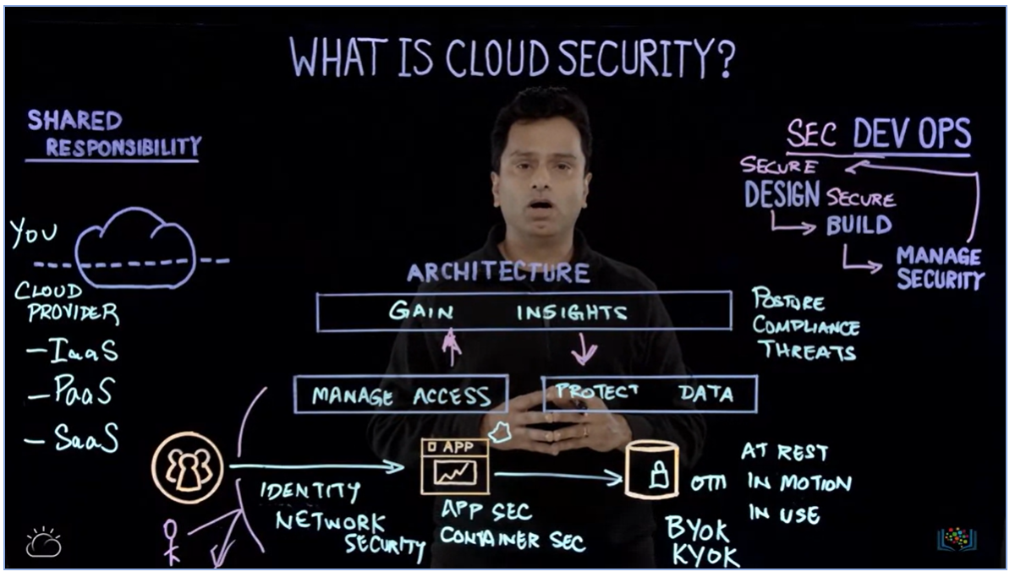 Identify access management

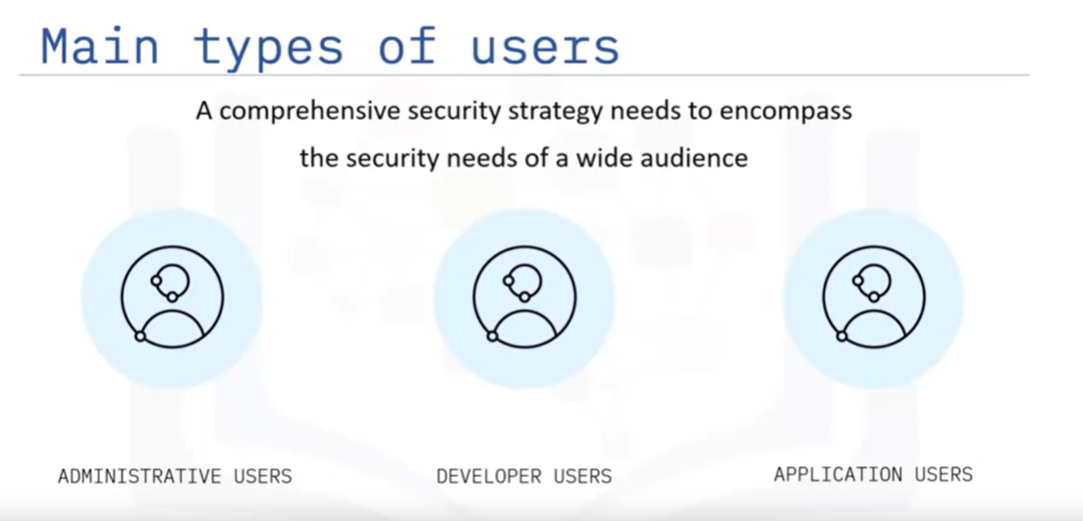

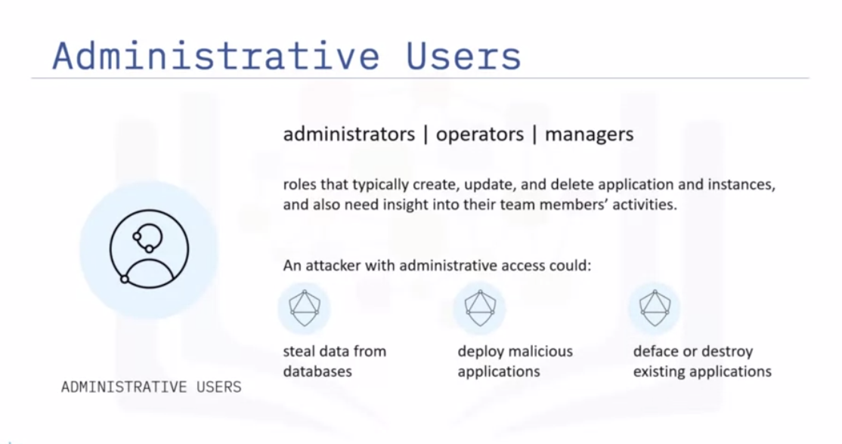 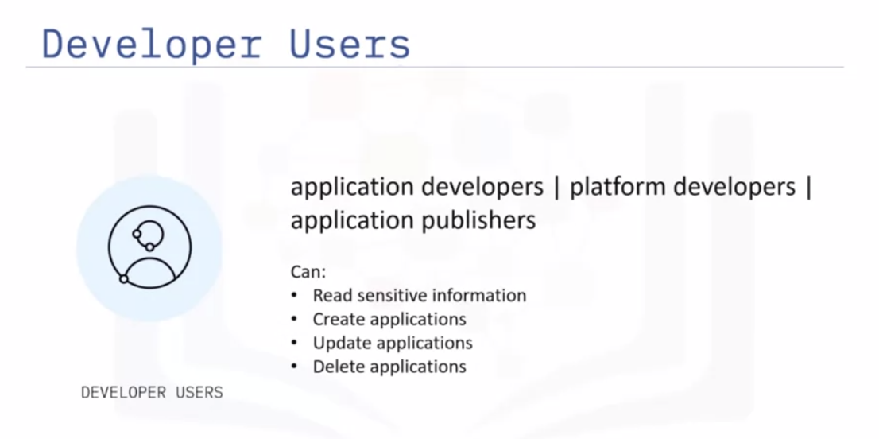 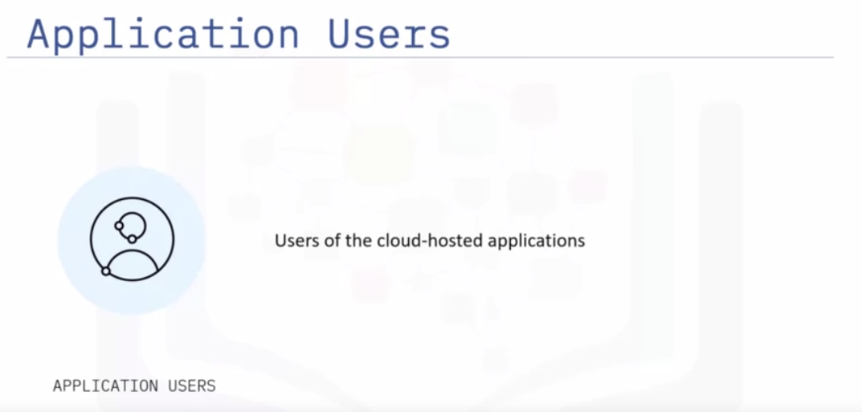 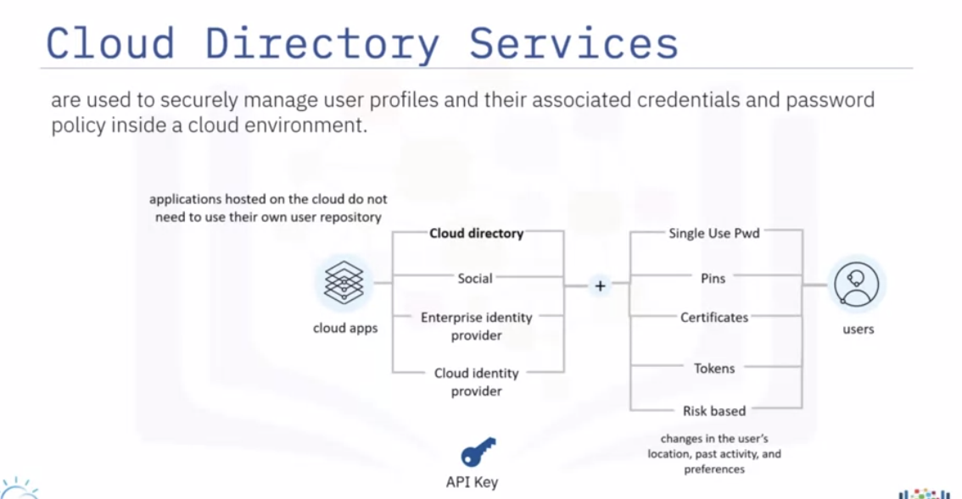 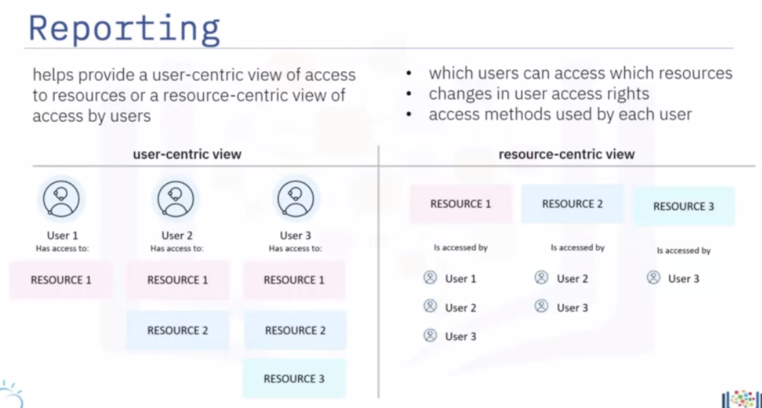

Encyption

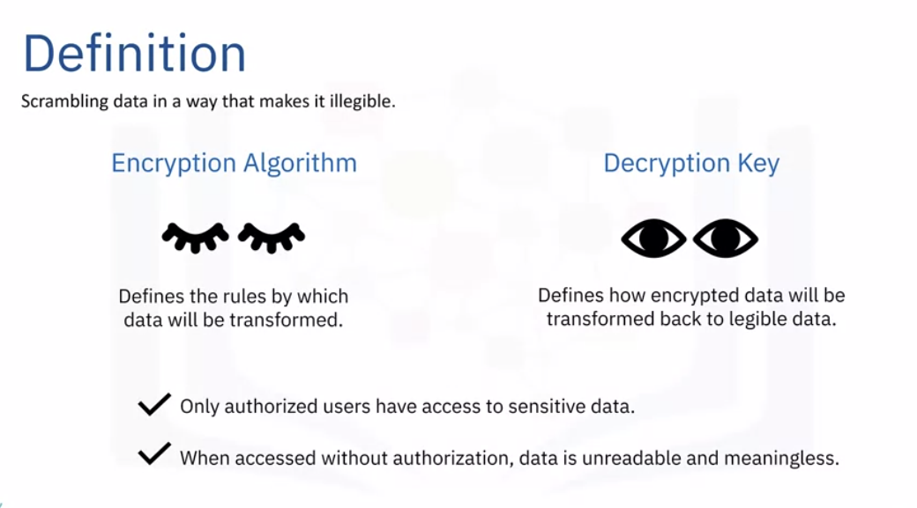 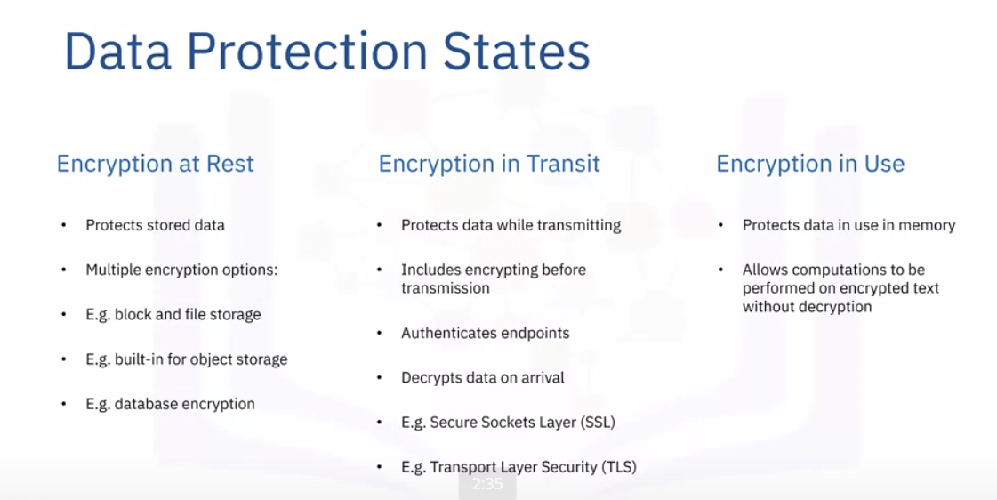 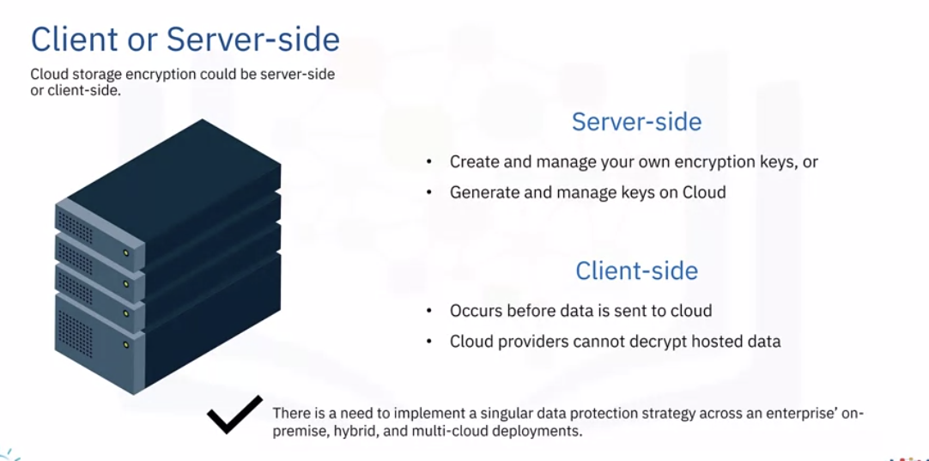 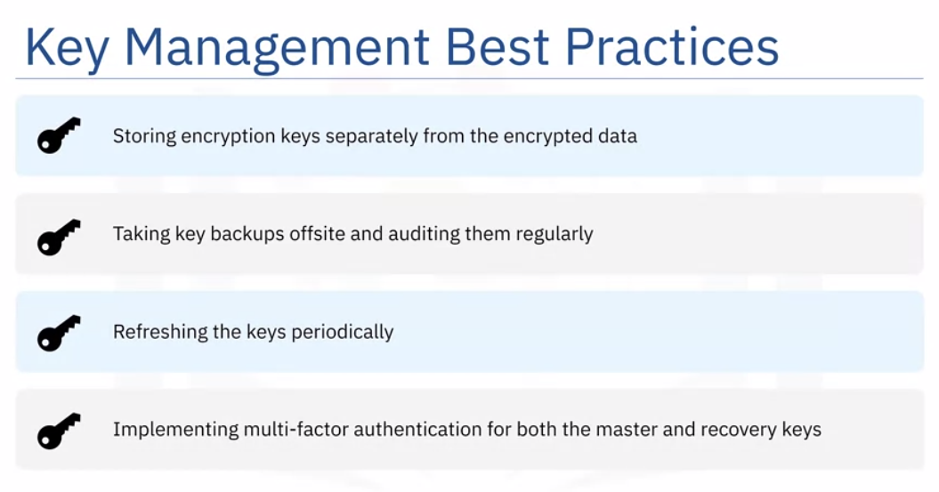

Cloud monitoring

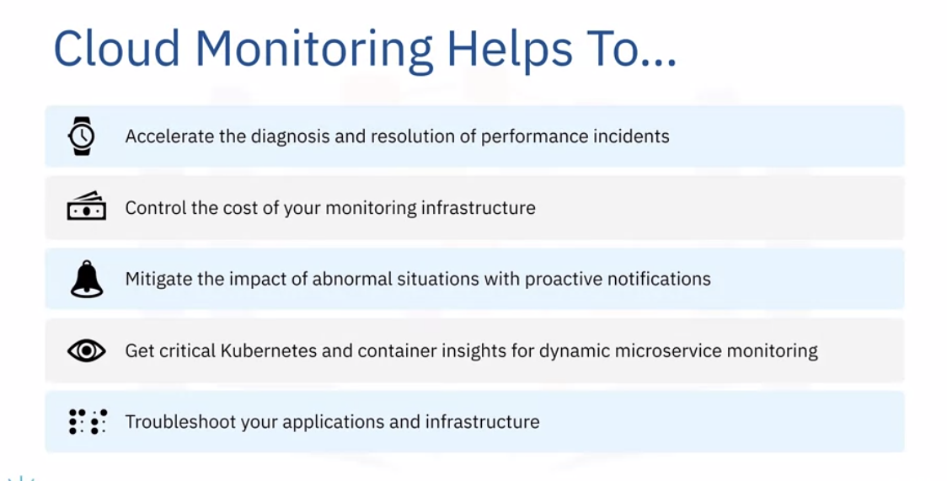 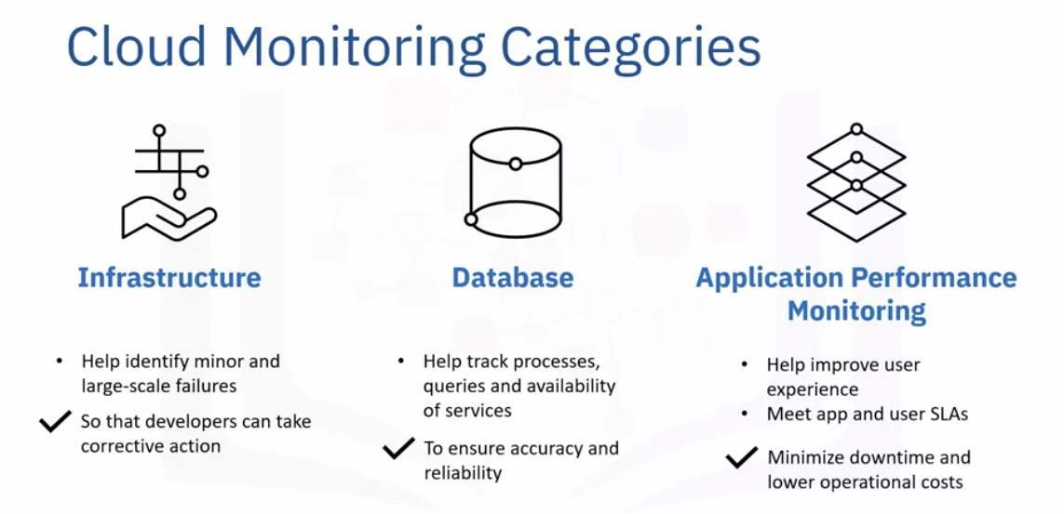

In this lesson, you have learned:

Cloud security refers to the policies, technological procedures, services, and solutions designed to secure the enterprise applications and data on cloud against insider threats, data breaches, compliance issues, and organized security threats.

Cloud security is a shared responsibility between the cloud provider and the user organization.

Security architecture and methods for achieving continuous security need to be embedded through the life cycle of an application to ensure that the application runs on a safe platform, the code is free from vulnerabilities, and the operational risks are understood.

Identity and Access Management, also known as access control, helps authenticate and authorize users, and provide user-specific access to cloud resources, services, and applications.

As part of their Identity and Access Management services, most cloud providers offer users the ability to define access groups and create access policies that define permissions for users on account resources.

Cloud encryption, often referred to as the last line of defense, not only encrypts data, but also provides robust data access control, key management, and certificate management.

Data needs encryption in three states -

- Encryption at rest; protecting data while it is stored

- Encryption in transit; protecting data while it is transmitted from one location to another

- Encryption in use; protecting data when it is in use in memory

There needs to be active monitoring of all connected systems and cloud-based services to maintain visibility of all data exchanges between public, private, and hybrid cloud environments. This ensures that the cloud provides a trusted platform that can securely integrate with your enterprise data centers.

Career opportunities in Cloud Computing

